Date: 15/08/2013
Here follows the only way to configure a 3 phase system using the Grid Converter assistant.
The Ideal Program is the VE Bus Quick Configure but for this document the VE Bus System Configurator will be used.
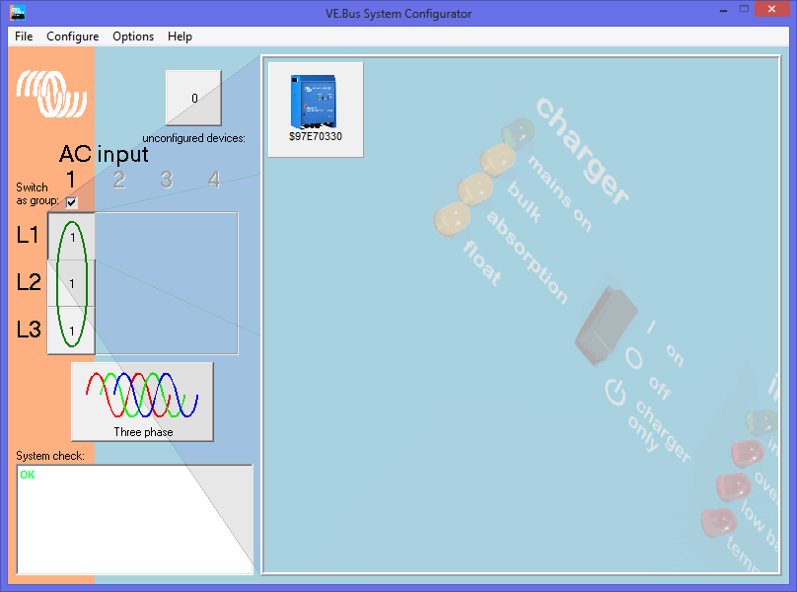
Select Phase 1 and right click to access VE Configure

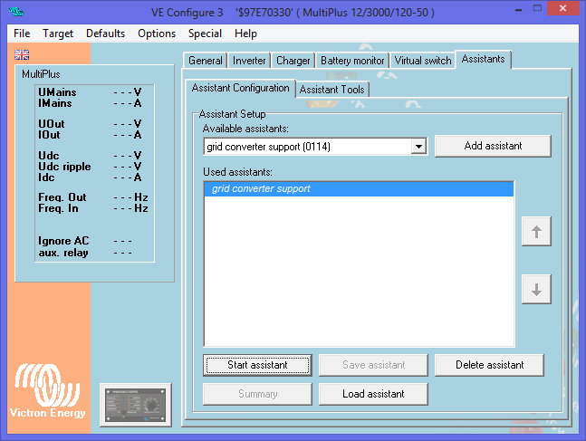
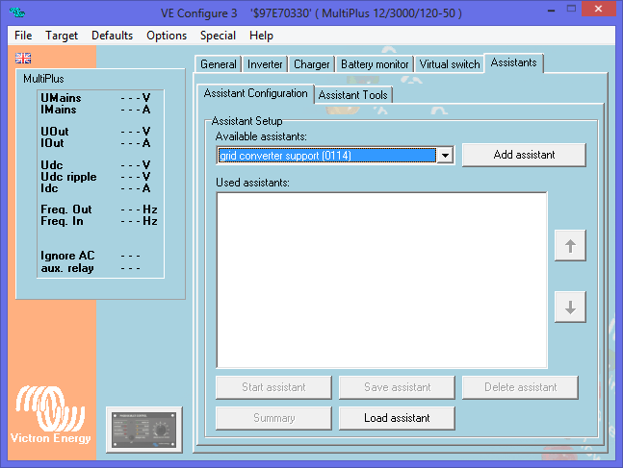
Start the assistant, read the welcome page carefully!
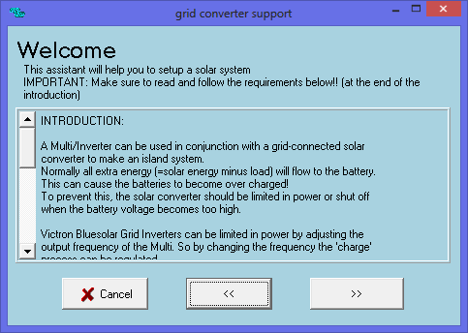
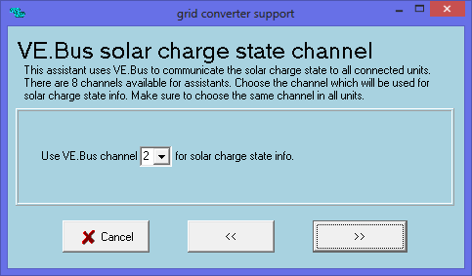
The Solar Charge Channel must stay at channel 2.

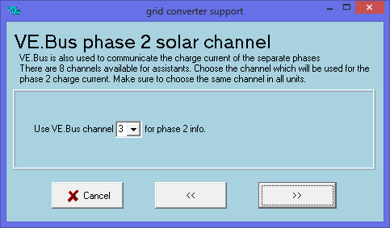
Phase 2 Solar Channel stays at 3.

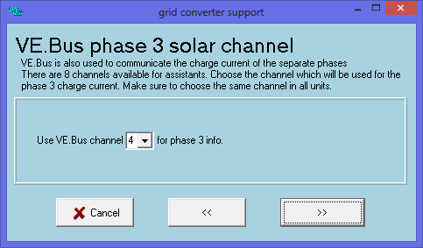
Phase 3 Solar Channel stays 4.

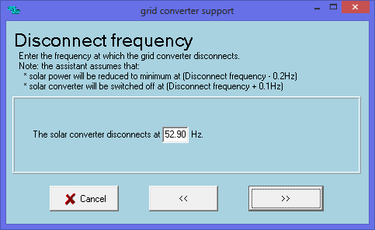
The Settings inside the Grid Inverter for Frequency control must be known, in smaller systems the start setting can be from 50.2 to 50.8 more or less and in bigger systems it can start at 51Hz. The Inverter/charger will only shift its frequency to just below the shutdown point to ensure the Grid Inverter stays on but stops producing power. In Smaller systems the shutdown point can be around 52hz and then again for bigger systems around 53Hz, these levels are only indications.
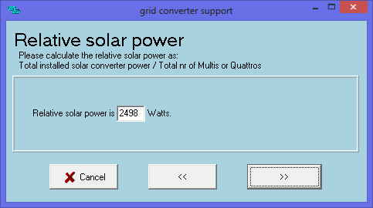
This value is the total installed PV Power divided by the number of Inverter/chargers.

